Cage Card Tags
Cage card tags are used as a method to disseminate information about animals within the cage.

Husbandry
Date of Birth Card
- Date of birth/Date to wean new litters
Separation Notice
- Cage separated by LAMS
- Separation due to overcrowding - service charge
- Separation due to health concerns - no service charge
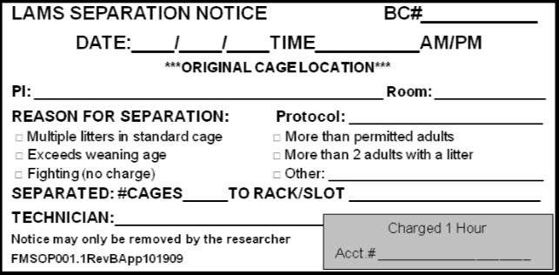
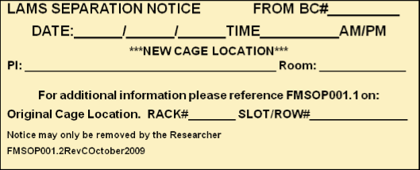
Overcrowded
- Cage exceeds the maximum limit
- Researcher is responsible for colony maintenance
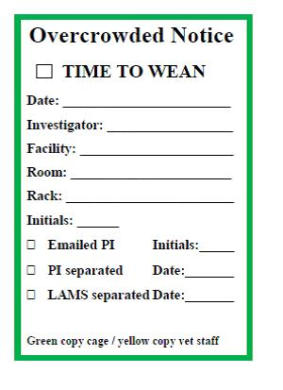

Death Notice
- Researcher must remove from cage or gray binder

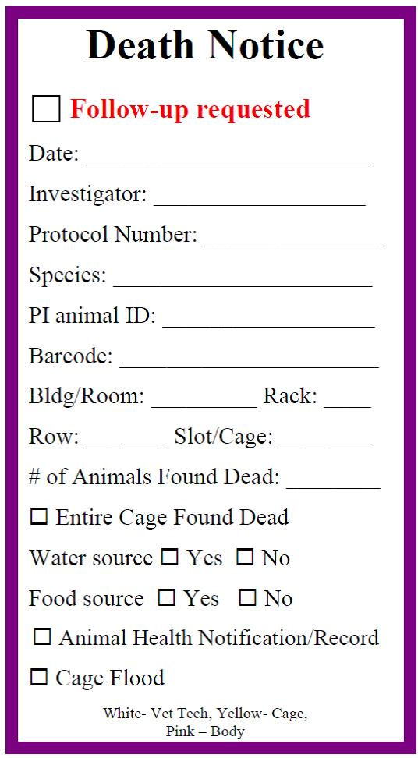

Veterinary
RA Check Me
- Animal requires Vet Tech assessment

HOT (Health Observation Tag)
- Animal requires observation of < 24hrs - LAMS will observe
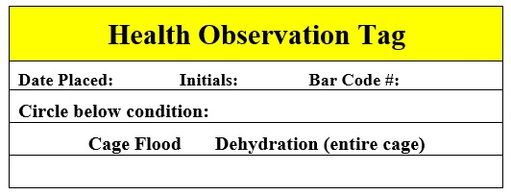
Handle with Care
- Special care needs to be used when handling animal
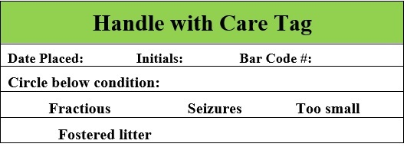

LAMS Health Notice
- Health issues that require monitoring or treatment
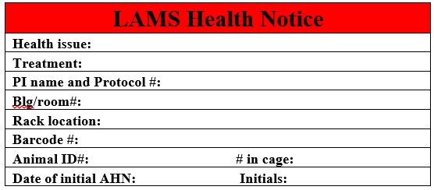
Rodent Survival Surgery Card
- For animals surviving greater than 6 hours following recovery, this card must be used. The cage card record must be complete and remain on the cage for the life of the rodent
