Room #
Primary Investigator:
Phone #

Biosafety Level 2
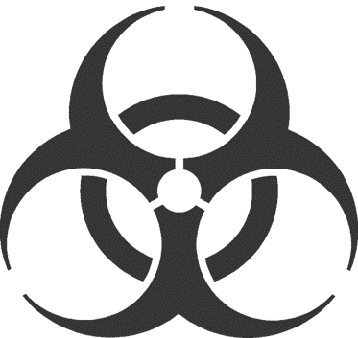
Moderate Containment / Moderate Risk
Admittance to Authorized Personnel Only

Human Derived Materials
(blood, bodily fluids, tissues or cells)
PPE and Universal Precautions for Entry/Exit:
Lab coat, gloves and mucous membrane protection are required when handling human blood or other potentially infectious materials.
Name | Phone
Emergency Contact





