Open Kuali Create Award

On the left side menu, click on Common Tasks ()

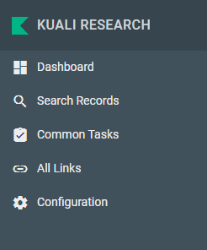

On the award card, select Search Award

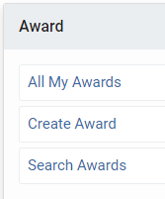

In the Award Search pop-up, enter the Kuali number in the Award ID field. Then click search.

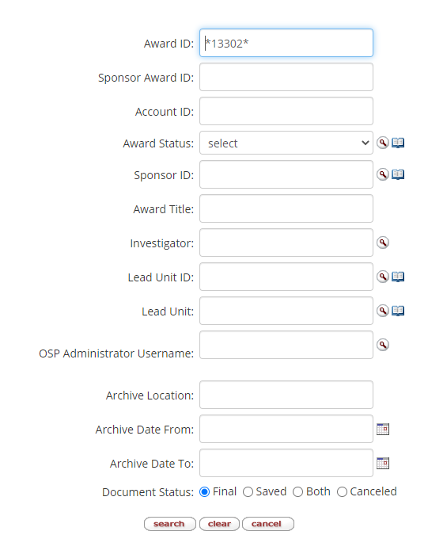

In the Actions box on the line for the award, right click Open. *Open in a new tab or window*

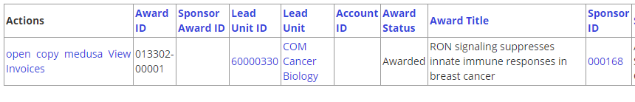

On the new browser tab, you will see the child level award record.

Click on the Comments, Notes and Attachments tab

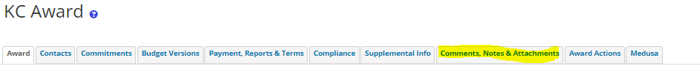

Notes:

Click the show button to open the notes section.

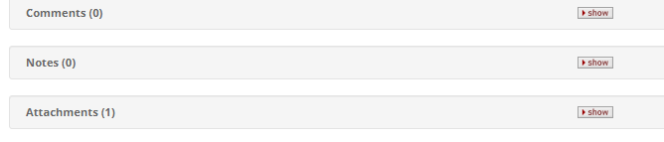

Add a note topic and the note text in the fields provided and click add to the right.

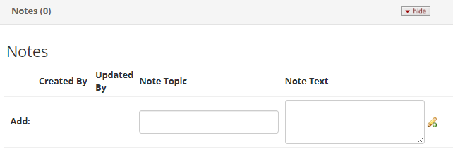 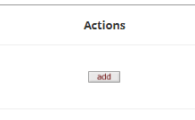

Click save at the bottom.

Attachments:

Click the show button to open the Attachments section.



Select an attachment type from the drop down, add a description if needed.

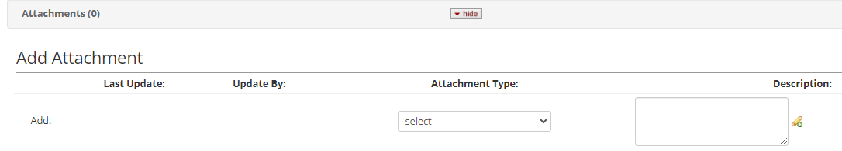

Click choose file and select the document from you saved location to upload it. Then click add to the right.

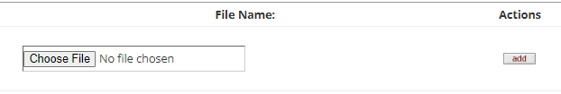

Click save at the bottom.

When you are done adding notes and attachment, click the close button at the bottom to get out of the record.

*If you do not have permission to do the tasks above, you will need to have your College Business Administrator submit a ticket to the [ERA Helpdesk](https://ituc.service-now.com/sp?id=sc_cat_item&sys_id=eab476de1b3564d0b4a776e1dd4bcb23&sysparm_category=71622bd51b29c810700fddf2cc4bcb65&catalog_id=-1) to request that permission be added for you.