**Labor Verification Annual Certification Process**

Introduction

Preparing for Annual Labor Verification Reviews

[Labor Verification Process Overview](#LVS" \o "Labor Verfification Process Overview)

Cost Sharing & Payroll Adjustments – Business Administrator Role

Performing Labor Verification

Labor Verification Status

Accessing Approved Statements

Labor Verification Reporting Tools

Definition of Liability

Email Notifications

Labor Verification Training

LVS Training, Federal & University Policy Links

**Introd****uction**

The federal government requires institutions to have a process in place to certify that salary expenses on federally funded sponsored projects represent an equitable distribution of charges based on an employee's work activities. The federal government requires that employee effort be reviewed and certified no less than annually. [Title 2 Code of Federal Regulations (2 CFR), part 200.328](https://www.ecfr.gov/cgi-bin/text-idx?SID=bef1d81f58571283f743fc43661a7f42&mc=true&node=se2.1.200_1328&rgn=div8)

In order to meet the set requirement, the University has developed an automated Labor Verification System. Effort is calculated directly from payroll roll records within the UCFlex Financial system and labor verification statements are reviewed and approved through the MSS tab. Using financial data from UCFlex provides greater accountability, accuracy, efficiency, transparency, and greater alignment with federal financial monitoring and reporting program performance requirements.

The automated Labor Verification process, allows Principal Investigators (PIs) to certify that salary expenditures are reasonable in relation to the work performed on sponsored projects or request salary changes if the effort is not reasonable.

**Preparing for Annual Labo****r Verification Reviews**

The Principle Investigator and Business Administrators (BA) fiduciary responsibilities include the review of costs charged to sponsored projects on a regular basis to ensure the appropriateness of expenses and prompt identification of errors so timely adjustments can be initiated.

The PI and Business Administrator (BA) are sent email notifications 60 days and 30 days prior to a statement being generated. Effort should be reviewed at this time, as this will ensure that the effort reported on the statement is correct when generated for review and approval.

Employee effort can be reviewed using the *LH740: LVS: Effort Summary by Grant/Employee* report which is located in BW in the Grants Management folder.

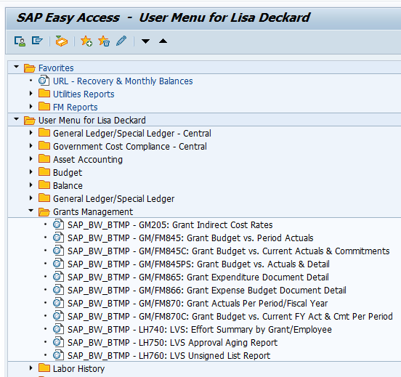

Enter the grant number assigned to the sponsored award and the budget period that needs to be reviewed and select OK.

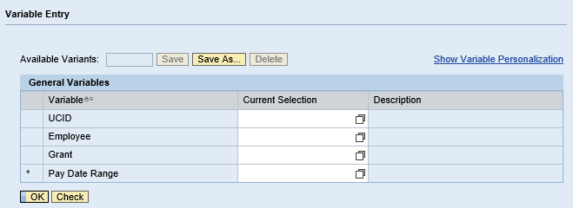

Enter Grant Number

Enter Budget Period

The LH740 LVS: Effort Summary by Grant/Employee report will display all direct salary and cost-shared salary for all employees that were directly charged to the grant during the time period entered.

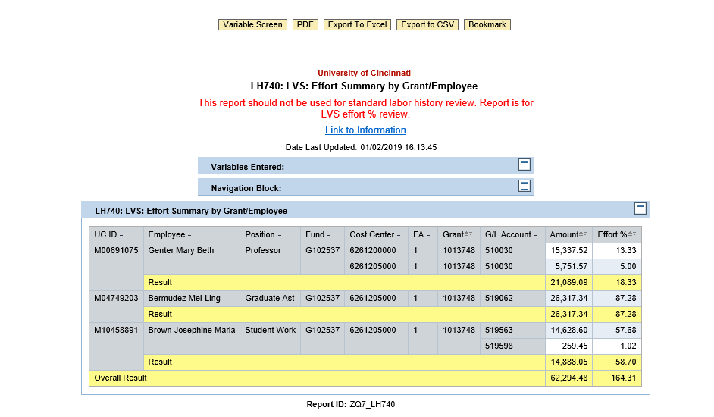

This report can be used during the sponsored projects budget year to monitor the effort being charged to the project.

Regular reviews will facilitate the Annual Payroll Certification process, and PIs will have confidence in the salary charges appearing on the annual report.

**Labor Verificati****on Process Overview**

Labor Verification Statements (LVS) are generated within UCFlex for each sponsored project and are generated at the end of each scheduled verification period. Statements are accessed through the MSS tab.

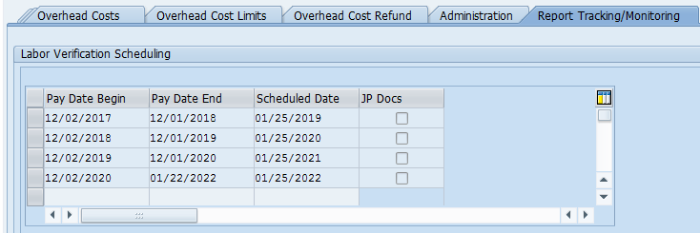Labor Verification Statements are based on the sponsored award’s project period. For example, an award with a project date of 12/02/2017 through 12/31/2021 would require four certifications:

Please note: In order to capture the prior month payroll data, the final statement of the project period will be sent on the 22nd of the month following the project end date. The example above has an 12/31/2021 project end date, therefore, the last LVS will go out on 1/22/2022.

Labor Verification Statements include all direct salary expenses by fund for all employees that have salary charged against the award. Cost Sharing and payroll adjustments are also included on the report.

After reviewing the list of employees, salary expenses, cost sharing, and payroll adjustments, principle investigators are asked to certify that the salary expenses are reasonable in relationship to the work performed by each employee, salary costs directly benefit the project and conform to the agency's terms and conditions, and that cost sharing requirements have been met.

**Cost Sharing & Payroll Adjustment****s – Business Administrator Role**

Sixty days and thirty days prior to the Labor Verification Statement being generated for the principle investigator to review, an email notification will be sent to the principle investigator and the business administrator.

Business Administrator roles:

* Ensure that sponsor imposed salary caps are calculated and salaries are recorded properly.
* Complete the on-line labor verification training.
* Review change requests from the principle investigator for Labor Verification Statements.
* Process any cost transfer requests for any direct salary adjustments needed on sponsored projects.
* Enter personal change requests (PCR) in UCflex for salary adjustments within 90 days after the close of the month in which the transaction occurred.
* Process any cost transfer requests for any cost-sharing adjustments needed on sponsored projects.
* Retain supporting documentation related to salary and effort distribution.

**Performing Lab****or Verification**

Labor Verification must be performed annually for all sponsored projects.

Annual labor verification statements are accessed within UCflex on the MSS tab. Principle Investigators will receive an email notification when a statement is generated.

* + **Access to Labor Verification Statements**
  + **Reviewing Labor Verification Statements**
  + **Performing Labor Verification Change Requests**
  + **Performing Labor Verification Approval**

***Access to Labor Verification Statements***

PIs receive email notifications when a sponsored project requires a labor verificationstatement to be reviewed and approved. The PI must have completed LVS training and assigned the LVS role in order to access the statement in UCflex.

UCFlex can be accessed using one of four browsers: Internet Explorer, Mozilla Firefox, Google Chrome, and Safari.

  
**Pop up blockers should be turned off before proceeding**

PIs access UCflex via the UCflex portal using their central login credentials.

The Labor Verification Statements are available in the Universal Worklist listed under MSS.

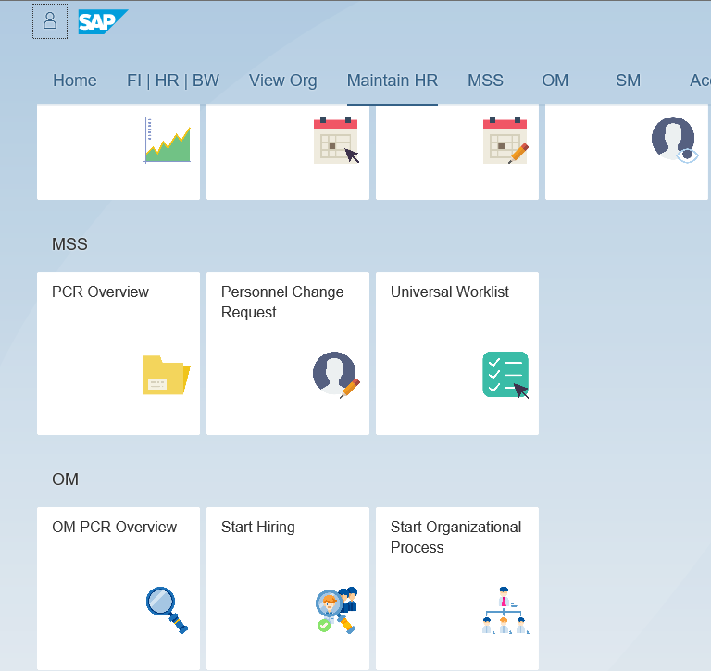

It is recommended to then select refresh  located on the top right side of the worklist to ensure that the MSS queue is showing up-to-date information.

Labor Verification Statements will be displayed for each sponsored project that needs to be reviewed.

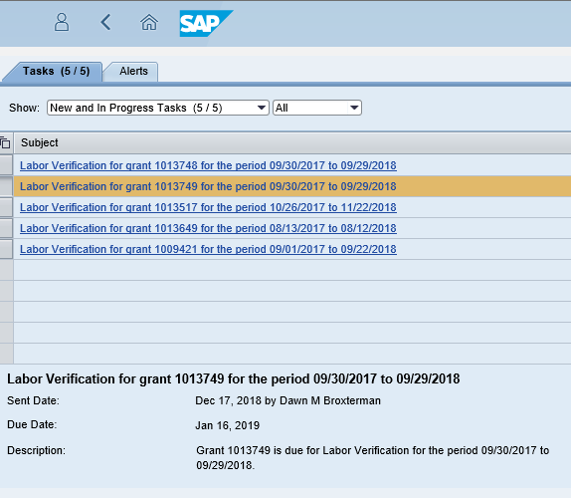

Click on the Labor Verification Statement link in the Subject section to open the labor verification statement.

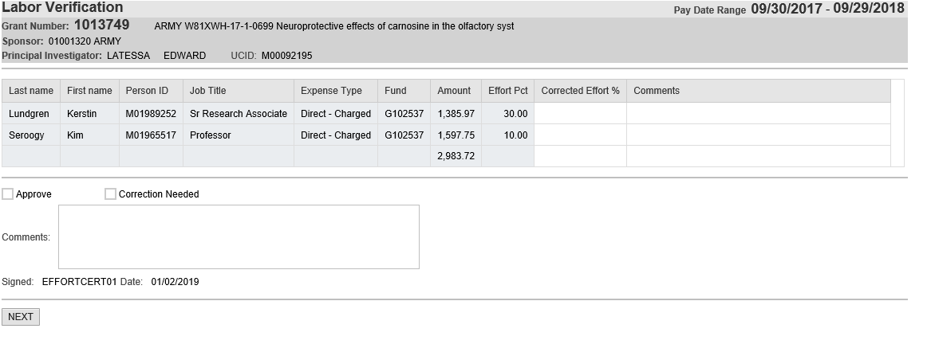

***Reviewing Labor Verification Statements***

Each Labor Verification Statement will display the salary expenditures by fund for every employee with direct salary for the sponsored award during the budget period that needs to be reviewed and approved.

PIs should review the following information to ensure expenses are reasonable based on the work performed on the project.:

* Employee Name
* Direct Salary Charges
* Cost Sharing Charges
* Payroll Adjustments
* Effort % (represents the amount of effort spent working on the sponsored award)

After completing review of the salary data the PI should determine if the effort is reasonable based on the work performed by the employee. Click the NEXT button at the bottom left side of the statement to proceed to the next step.



***Performing Labor Verification Change Request***

If the effort is not reasonable the PI should enter the correct effort % and comments, then select the box next to Correction Needed. Click the **NEXT** button to move to the next step.

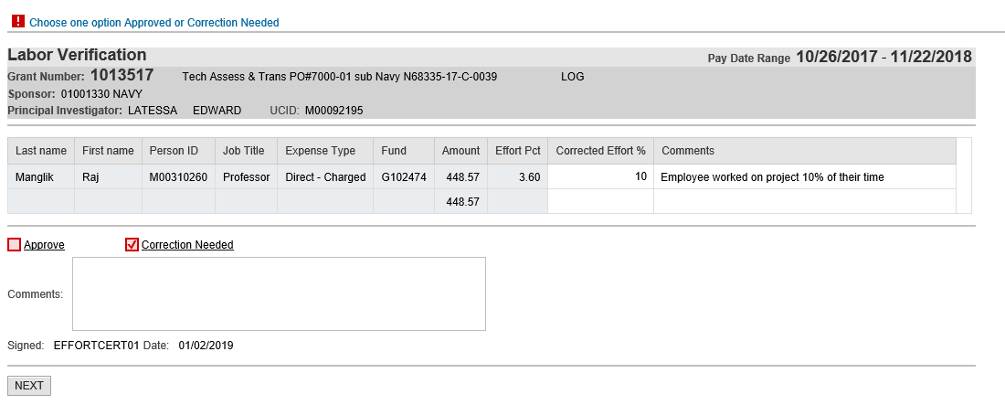

Click **SAVE** to complete the change request.

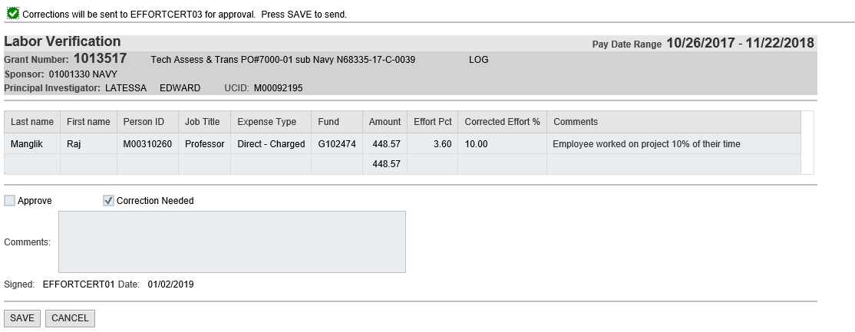

The statement will be forwarded to the business administrator. The business administrator will process any needed change requests.

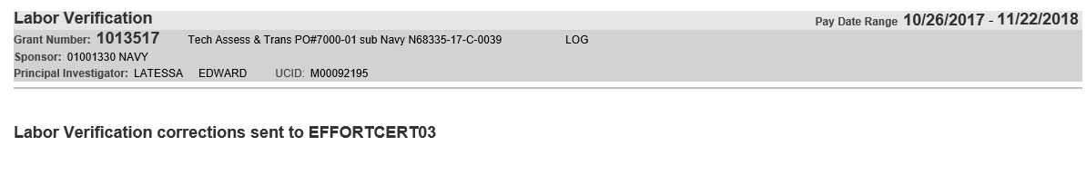

***Performing Labor Verification Approval***

If the effort is reasonable based on the work performed by the employee, then select the box next to Approve. (see definition of liability for PI’s liability when approving LVS)

Click the **NEXT** button to move to the next step.

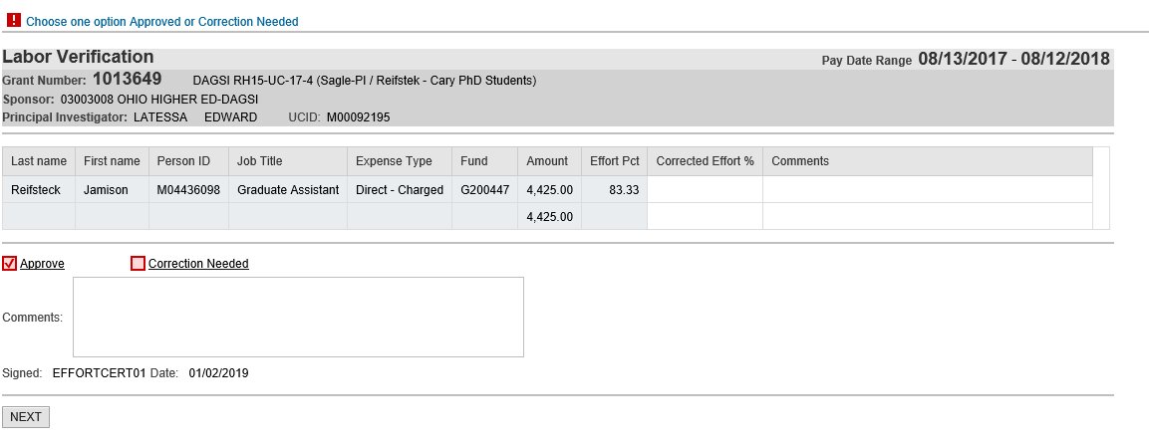

Click **SAVE** to complete the verification.

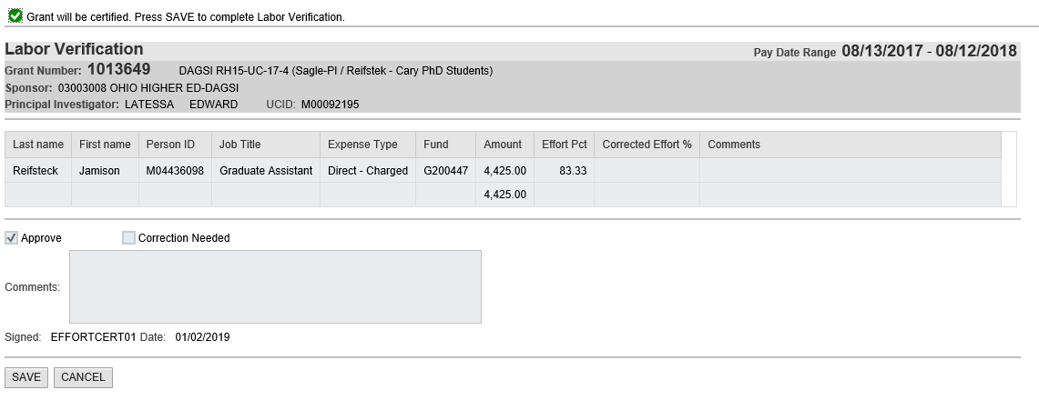

The Labor Verification Statement has now been reviewed and approved by the PI and is complete.

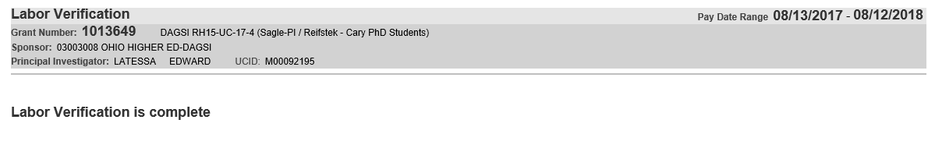

**Labor Verifi****cation Status**

The status of the LVS can be found on the report tracking/monitoring tab in the grants master data record (GMGRANTD) and can be accessed by logging into R/3 through UCflex.

APPROVED – LVS has been approved by the Principal Investigator (PI)

CANCELLED – LVS has been cancelled.

NODATA - No data was found within labor history for the grant and period for which the LVS was scheduled.

CHGREQUEST - The PI sent the LVS to the business administrator requesting an effort change be made to the LVS. When the LVS is in this status the LVS is in the department administrator’s Universal Work List (UWL) within UCFlex MSS.

CHGAPPROVE - The department administrator processed and approved the requested change to be made to the LVS. When the LVS is in this status the program will wait until changes are found within labor history for the grant and grant period and then will automatically send the updated LVS to the PI.

CHGREJECT - The department administrator rejected the change requested by the PI and the LVS was sent back to the PI. When the LVS is in this status the LVS is in the principle investigator’s Universal Work List (UWL) within UCFlex MSS.

STARTED - The LVS process has been started and is with the PI. When the LVS is in this status the LVS is in the principle investigator’s Universal Work List (UWL) within UCFlex MSS.

RESTARTED - An updated LVS had been sent to the PI after payroll ran with updates after department administrator’s approval. When the LVS is in this status the LVS is in the principle investigator’s Universal Work List (UWL) within UCFlex MSS.

RECERTIFY - A revised LVS has been provided to the PI after a payroll change on a grant and period that had already been approved. When the LVS is in this status the LVS is in the principle investigator’s Universal Work List (UWL) within UCFlex MSS.

**Accessing App****roved Statements**

Electronic records of the approved statement will be retained for audit purposes. Approved Labor Verification Statements can be viewed in UCflex from R/3.

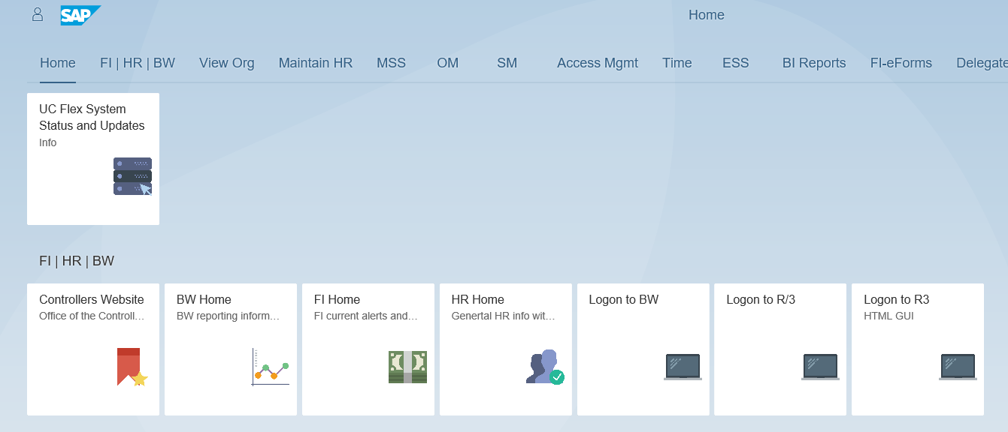

Select Decentral Financial Reports and Display>Grants>Master Data>GMGRANTD to access the sponsored award master data record.

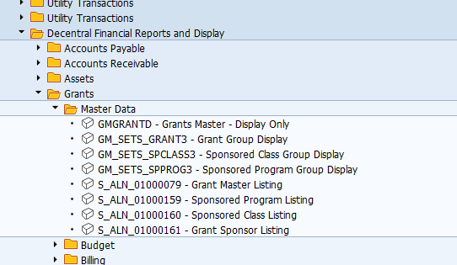

Enter the grant number assigned to the project and Enter.

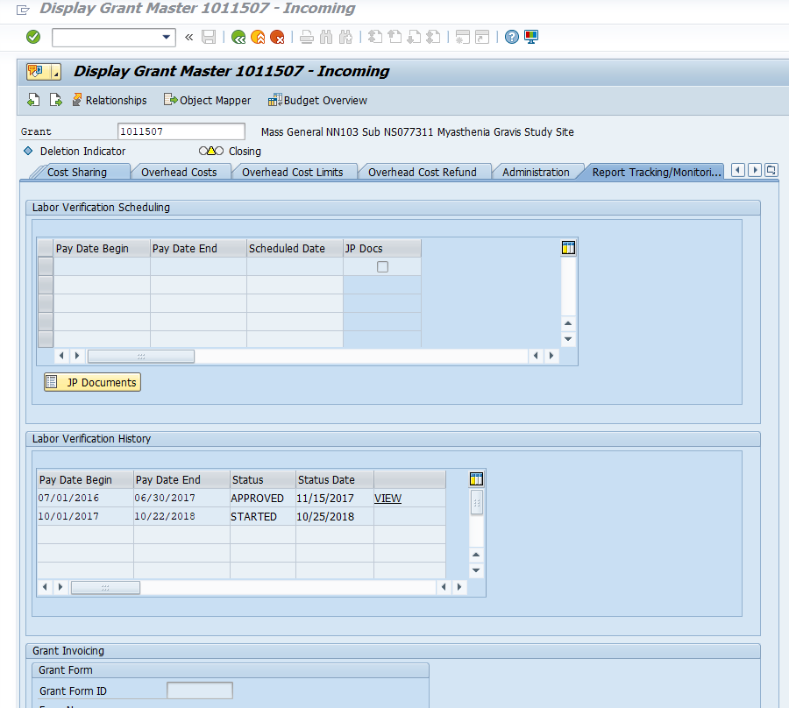Go the the **Report Tracking/Monitoring tab** to view the approved Labor Verification Statement.

Click **VIEW** to display the approved statement.

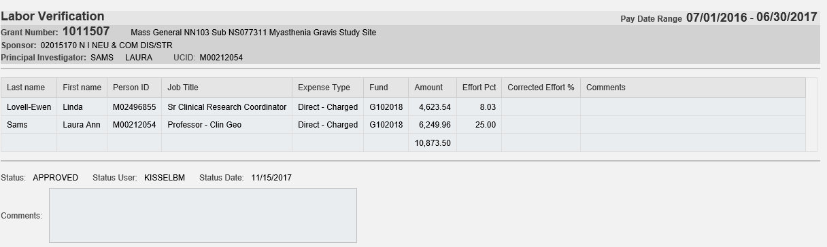

Statements can be converted to PDF and printed from this screen. Click the Convert to PDF button located in the left-hand corner to convert to PDF for printing.

**Labor Verificati****on Reporting Tools**

Reports have been developed within UCflex to assist with reviewing the effort and salary reported on the labor verification statements.

**Labor Verification Effort Calculations:** Direct salary expenses, cost-sharing, and effort percentages posted against a sponsored award can be viewed using the *LH740: LVS: Effort Summary by Grant/Employee* report. This report can be accessed through UCflex by logging into BW. The report is located in the grants management folder.

This interactive report provides direct salary expense, cost-sharing, and calculated effort by employee and can be ran for any selected time period.

This report will display the same effort reflected on the Labor Verification Statement when ran for the time period of the statement.

This is the effort % reported on the LVS

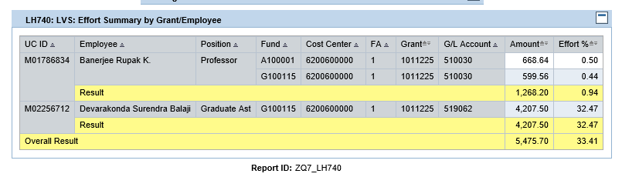

**Outstanding Labor Verification Statements**: The status of all outstanding statements can be viewed using the LH760 LVS Unsigned List Report. This report can be accessed through UCflex by logging into BW. The report is located in the grants management folder.

This report will display all outstanding statements for the selected principle investigator or business administrator.

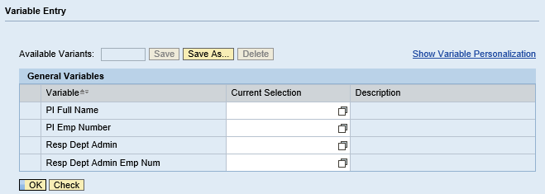

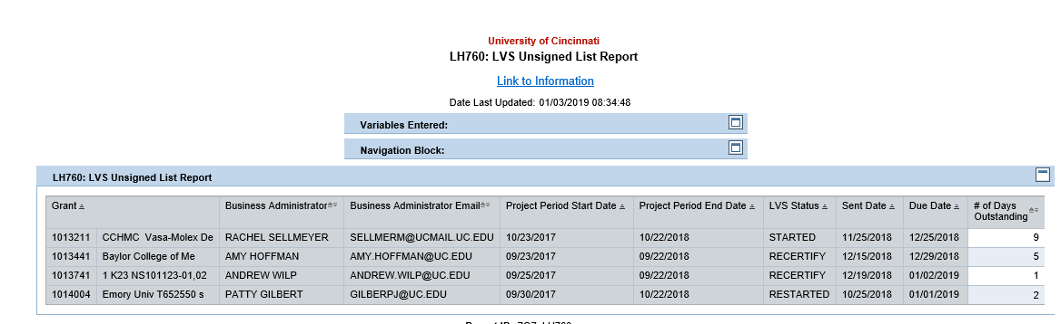The LH760: LVS Unsigned List Report will display all grants that are currently outstanding for the selected PI or BA. The report includes the project period being reviewed, the status of the statement, the sent date, and due date and the number of days past due. Principle investigators are given 30 days to approve statements. This report will display the number days over the 30 days.

**Definition of “Liability” As****sociated with Certifications**

Approvals made to the Labor Verification Statements are good faith acknowledgments. This means there is a reasonable belief the financial/salary information that is personally known to the approver is accurate.

With respect to the financial/salary information that is not personally known to the Certifier, it is appropriate for the Certifier to rely on the financial/salary information provided when s/he has no personal knowledge of inaccuracies/weaknesses.

There is a **personal liability only if the Certifier has knowingly provided an untrue certification**, i.e. has engaged in intentional fraud or deliberate unlawful conduct. If there has been negligence by the support staff that has resulted in an error that is not obvious and not known to the Certifier, no personal liability would be attached to the Certifier.

**LVS Email N****otifications**

Notifications concerning Labor Verifications are sent as follows:

The below email will be sent to the principle investigator and the business administrator 60 days before the LVS is generated. This notification is an automatically generated email from UCflex.

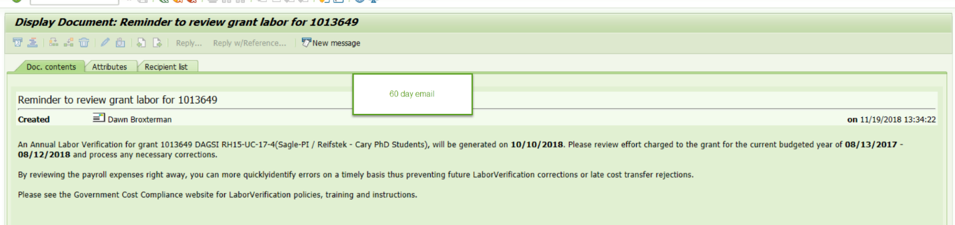

The below email will be sent to the principle investigator and the business administrator 30 days before the LVS is generated. This notification is an automatically generated email from UCflex.

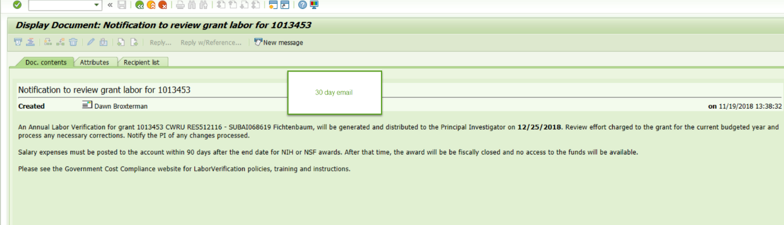

The below email will be sent to the principle investigator and the business administrator when the statement is generated and ready to be reviewed by the PI. This notification is an automatically generated email from UCflex.

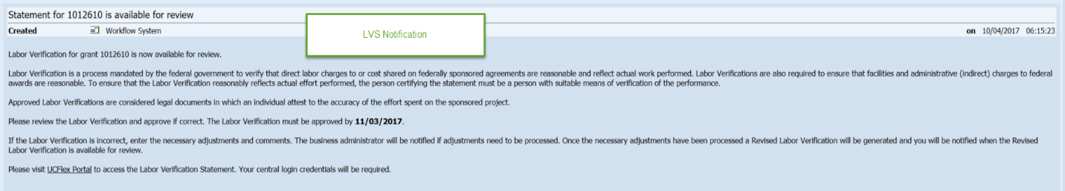

When a change request has been requested by the PI the business administrator will receive the following email notification. This notification is an automatically generated email from UCflex.

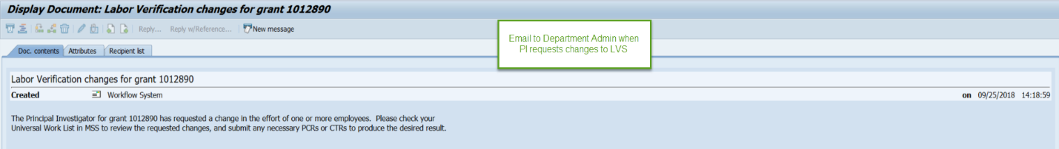

If a statement has not been approved within 30 days from the day generated the following email notification will be sent to the principle investigator and the business administrator the day after the statement was due. This notification is an automatically generated email from UCflex.

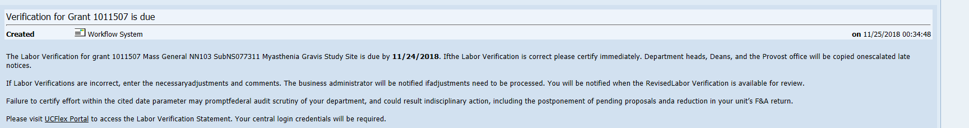

Once the requested changes are processed in UCflex, a new LVS is generated and the following email notification will be sent to the principle investigator and the business administrator. This notification is an automatically generated email from UCflex.

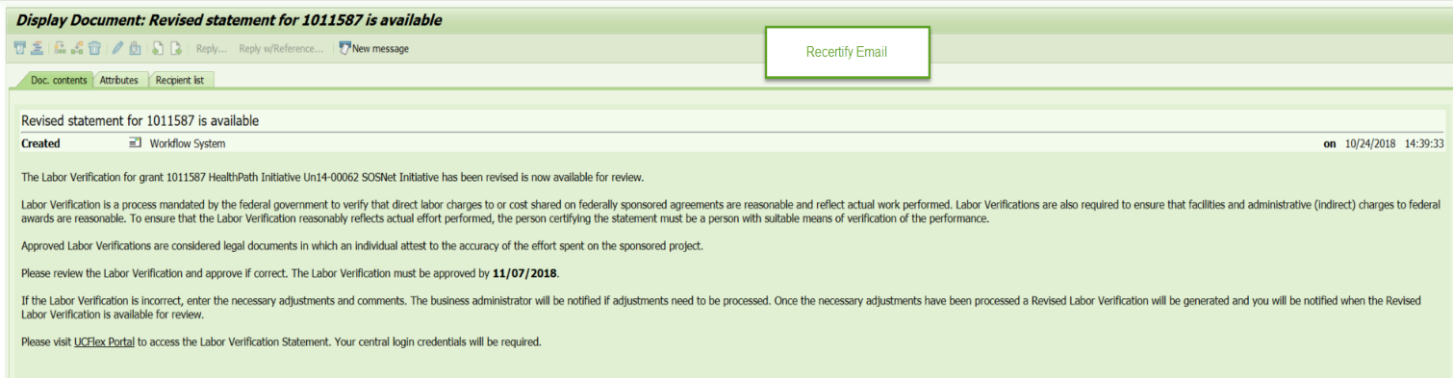

If payroll changes have been processed for a previously approved labor verification statement, a new statement will be generated and the following notification will be sent to the principle investigator and the business administrator.

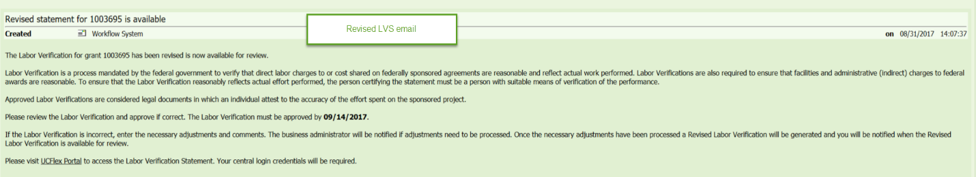

An email will be sent to all new principle investigators and business administrators working on sponsored awards are required them to review all related LVS policies and procedures and to complete the on-line training tutorial.

An email will be sent to the principle investigator when a statement is 14 days past the LVS due date. The business administrator will be copied on this late notice. This late notice will be sent from the Government Cost Compliance Department.

An email will be sent to the principle investigator when a statement is 28 days past the LVS due date. The business administrator and department head will be copied on this late notice. This late notice will be sent from the Government Cost Compliance Department.

An email will be sent to the principle investigator when a statement is 42 days past the LVS due date. The business administrator, and department head, and dean will be copied on this late notice. This late notice will be sent from the Government Cost Compliance Department.

An email will be sent to the principle investigator when a statement is 49 days past the LVS due date. The business administrator, and department head, dean, and provost will be copied on this late notice. This late notice will be sent from the Government Cost Compliance Department.

**Labor Verifica****tion Training**

All principle investigators and business administrators are required to complete labor verification training. This training consists of an on-line tutorial. PIs and BA’s will be required to read the policies and procedures governing the labor verification process and complete the on-line training tutorial. The PI or BA must notify Government Cost Compliance Department (GCC) that training has been completed and GCC will issues the LVS role to the individual.

**Labor Verification & Rel****ated University Policy Links**

[Labor Verification on Sponsored Projects Policy](http://researchhow2.uc.edu/home/browse-by-offices/government-cost-compliance)

[Online Labor Verification Training](https://catalysthelp.uc.edu/training/lvs-project/story_flash.html)

[Effort Commitment Policy](https://www.uc.edu/content/dam/uc/af/financialpolicies/Docs/effortcomm_pol.pdf)

[Cost Transfer Policy](https://www.uc.edu/content/dam/uc/af/financialpolicies/Docs/costxfer_pol.pdf)

[Title 2 Code of Federal Regulations (2 CFR), part 200.328](https://www.ecfr.gov/cgi-bin/text-idx?SID=bef1d81f58571283f743fc43661a7f42&mc=true&node=se2.1.200_1328&rgn=div8)