 | Room #
PI : | Phone #

Biosafety Level 2
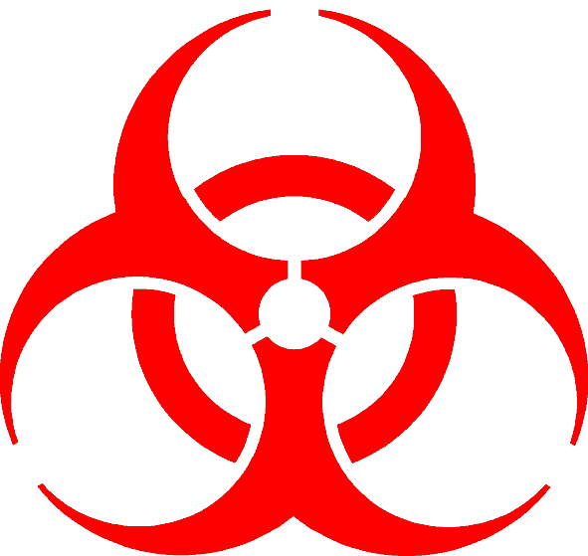
Moderate Containment / Moderate Risk
Admittance to Authorized Personnel Only

Biohazard Item(s):
Special Procedures, PPE or Precautions for Entry/Exit:
Emergency Contact
Name | Phone

