SECTION 1.0: Instructions
Advarra Submission instructions: Per UC IRB’s requirements, this cover page must be present with your Advarra submission. Please obtain signature from UC IRB. You may submit this signed cover page and all required submission documents via Advarra’s Center for IRB Intelligence (CIRBI) Platform on the Documents Attachment Summary page under no. 3, “IRB Waiver of Oversight”.

If you are not already registered with CIRBI, please be sure to enter “UCHealth/University of Cincinnati” as your organization/company name in CIRBI (as shown below). Please do not include your individual department.

SECTION 2.0: Study contacts
UC IRB requires to be cc’d for all communications related to your Advarra submission. In order to do this, please follow these instructions below:

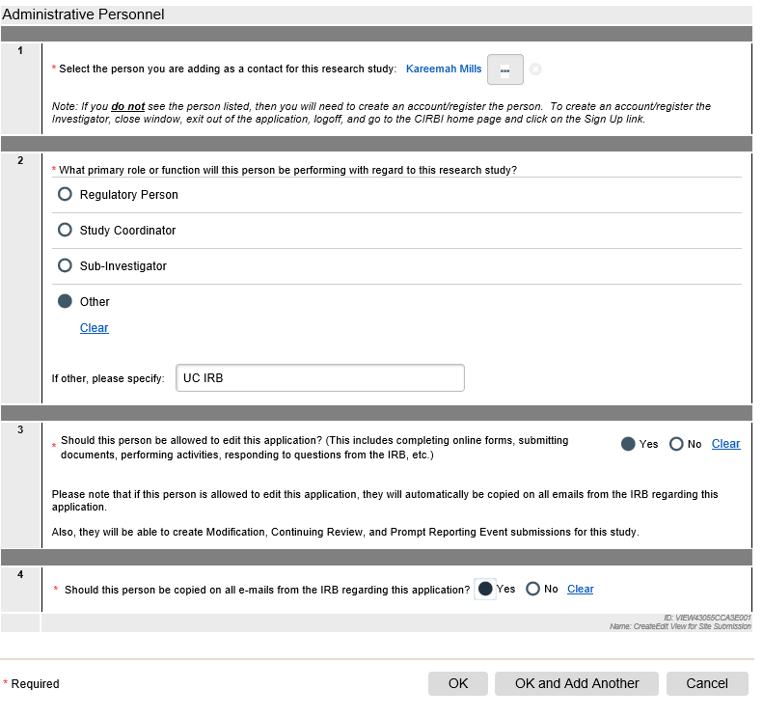
On page 3 of the submission form, titled “Investigational/Research Location(s) and Subject Recruitment” under no. 2, add Kareemah Mills (irb@uc.edu) to your submission as shown below. Be sure to select “yes” to questions 3 and 4.

Section 3.0 Informed Consent Template Language

Please indicate below how the HIPAA Authorization Language will be presented to subjects:
- The HIPAA Authorization language is incorporated in the submitted ICF: (Y/N)
- A separate HIPPA Authorizaiton Form will be given to subjects: (Y/N)

Please indicate the type of sponsor compensation for injury language:
- The sponsor will pay for emergency care of study related injuries: (Y/N)
- The sponsor will pay for any study related injuries: (Y/N)

Please indicate if there is a risk of Hepatitis B reactivation from study drugs: (Y/N)

SECTION 4.0: Institutional Deferral
Cover page completed by:

Site main point of contact Principal Investigator

Protocol #, Sponsor Name Study Title

UC ePAS#

This signature is to confirm that the UCHealth/University of Cincinnati IRB is aware of this site’s submission to Advarra for the above-mentioned protocol:

Signature: Signature Date (mm/dd/yy)
Angela Braggs-Brown, RAC, CIP
Director, Human Research Protection Program

Or Authorized Designee:
Kareemah Mills, CIP
Assistant Director, Human Research Protection Program

