Assent Form for Research
University of Cincinnati
Department: __________________________________
Principal Investigator: _______________________________
Faculty Advisor: ________________________________

Title of Study: ___________________________________________________________

State the general activity the participants will do and provide corresponding image.  EXAMPLE: We will talk. | 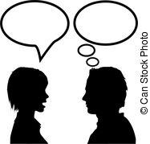
Include the following statement and image.

You can say yes or no.

State any direct benefits because of participation in the study and provide corresponding image.

EXAMPLE: You might learn to talk more.

Identify how long the activities take and provide corresponding image.  EXAMPLE: It will take about 10 minutes. | 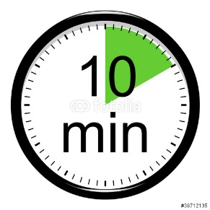
State additional activities the participants will do and provide corresponding image.

EXAMPLE: We will talk during art or puzzles.

Include the following statement and image.

If you have any questions you can ask (PI’s first name) and (Co-PI’s first name, if applicable).

Include the following statement and image.

You do not have to be in this (general activity listed above). You may stop. No one will be mad or sad with you.

Include the following statement and image.

To stop you can tell (PI’s first name) and (Co-PI’s first name, if applicable).

Include the following statement and image.

If you want to (general activity listed above), write your name. If you do not want to (general activity listed above), do not.

Your Name (please print) ____________________________________________

Your Birthday ________________ (Month / Day / Year)

Your Signature ___________________________________________ Date ___________

___Oral presentation of the assent was given to the participant, who was not able to read the written assent. By signing, I certify that the oral presentation was consistent with this written document.

___Oral presentation of the assent was given to the participant, who was not able to read the written assent. By signing, I certify that the oral presentation was consistent with this written document.

_______________________________________________________________________
Impartial Witness Signature (oral presentation only) Date

Signature of Person Obtaining Assent _____________________________ Date ___________

